Question
Module 2 – OOSAD with UML
Chapter 05: Modeling Concepts

Question 1

What is a Model? Why a model is used?

Answer:
In IS development, the main focus of both analysis and design activities is on models. A model is an abstraction of a system or sub-system from a particular perspective or view. A model provides a view of a system or sub-system at a particular stage in IS development activities. A model is complete and consistent at the chosen level of abstraction.
Usefulness of models:
- A model is quicker and easier to build
- A model can be used in a simulation
- A model can evolve as we learn
- We can choose which details to include in a model
- A model can represent real or imaginary things from any domain

Question 2

What is a diagram? Why a diagram is used?

Answer:
Abstract shapes are used to represent things or actions from the real world. Diagrams follow rules or standards. A single diagram is used to illustrate or document some aspect of system and one more diagrams collectively form a model to represent a complete view of a system from a particular viewpoint.
Diagrammatical models are used in order to:
- communicate idea
- generate new ideas and possibilities
- test ideas and predictions
- understand structures and relationships

Question 3

Write down the difference between a model and a diagram?

Answer:
Differences between diagrams and models
- A diagram illustrates some aspect of a system.
- A model provides a complete view of a system at a particular stage and from a particular perspective.
- A model may consist of a single diagram, but most consist of many related diagrams and supporting data and documentation

Question 4

Why standard are important in diagrams?

Answer:
Diagrams follow rules or standards. What shapes should be used in a particular diagram are laid down in standards.
Importance of standards:
The standards make sure that different people will interpret the diagram in the same way. They promote communication in the same way as a common language. They also promote communication over time.
[UML standards are laid down in the OMG Open Modeling Language Specification (OMG, 2001).]

Question 5

Mention the general rules that designers should follow for modeling. OR Write down the rules that modeling techniques should enforce.

Answer:
Some general rules that designers of models should enforce:
- Simplicity of representation – only showing what needs to be shown
- Internal consistency-within a set of diagrams
- Completeness-showing all that needs to be shown
- Hierarchical representation-breaking the system down and showing more detail at lower levels

Question 6

What is the notation for each of the following: package, sub-system and model?

Answer:
Use Cases
Use Case
Model
Campaign
Management
Package
Model
Sub-system

Question 7

Name the elements that make up a UML diagram
Answer:
Elements are:
- Icons
- Two-dimensional symbols
- Paths
- strings

Question 8

What is a UML package? What is its purpose?
Answer:
A package is a mechanism for grouping UML elements, usually classes, into groups. Packages can be nested within other packages.
Usefulness:
A UML package provides a way of organizing model elements. It does not represent things in the system that is being modeled, but is a convenience from grouping together elements that do not represent things in the system.

Question 9

Write down the features of a requirement model, behavioural model?
Answer:
Requirements Model
- complete view of requirements
- may include other models, such as a Use Case Model
- includes textual description as well as sets of diagrams
Behavioural Model
- shows how the system responds to events in the outside world and the passage of time
- an initial model may just use Collaboration Diagrams
- a later model will include Sequence Diagrams and Statecharts

Question 10

What is an activity? What is an Activity diagram? What are its purposes?
Answer:
An activity is some behaviour that may persist for duration of a state.
An activity diagram focuses on a flow activity driven by internal processing within an object. In an activity diagram most sates are action states and each of them represents an execution of an operation.

Question 11

What is the notation used for an activity in UML activity diagram?
Answer:
A rectangle with rounded ends is used to represent an action.

An activity

Question 12

In what two ways decisions can be represented in a UML activity diagram?
Answer:
One Way of decision:
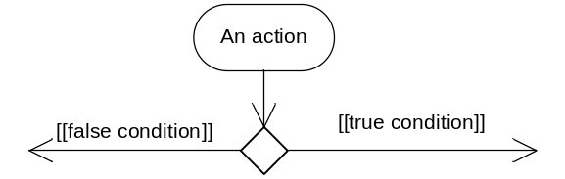
Alternative way:
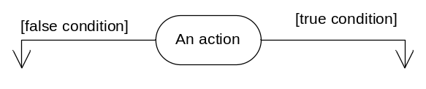

Question 13

What is a guard condition? What is an object flow?
Answer:
Guard condition: A guard condition is a Boolean expression associated with a transition that is evaluated at the time the event fires. The transition is take place if the condition is true.
Object flow: An object is a dependency between an object and an activity that results in a change to the state of that object.
[Use figure of notations for Guard condition and Object flow]

Question 14

What is USDP? What best practices are included in USDP?
Answer:
USDP stands for Unified Software Development Process. It is developed by the team that created UML. It embodies best practice in system development and adopts an iterative approach with four main phases. In USDP, different tasks are captured in a series of workflows.
USDP includes currently accepted best practices in information system development. These include:
- Iterative and incremental development
- Component-based development
- Requirements-driven development
- Configurability
- Architecture-centrism
- Visual modelling techniques

Question 15

Write down underlying principles and activities of USDP. What are phases in USDP?
Answer:
Key principles:
- Iterative
- Incremental
- Requirements driven
- Component-based
- Architectural
Main activities:
- Requirements Capture and Modelling
- Requirements Analysis
- System Design
- Class Design
- User Interface Design
- Data Management Design
- Construction
- Testing
- Implementation
There are four phases. They are:
- Inception
- Elaboration
- Construction
- Transition

Question 16

Differentiate USDP from Traditional Development process?

Answer:
Differences:
- In a waterfall life cycle project the phases and the workflows are linked together
- In the Requirements phase, only Requirements workflow activities are carried out
- All Requirements activity should be completed before work starts on Analysis
- In an iterative life cycle project it is recognised that some Requirements work will be happening alongside Analysis work

